Tokyo Tech Small Satellite Development Projects

- Cute-1.7 and TSUBAME -
○Katsutoshi Imai, Naoki Miyashita, Masafumi Iai, Kuniyuki Omagari, Masashi Asami, Wataru Miyazawa, Hideyuki Yabe, Kei Miyamoto, Takeshi Usuda, Ken Fujiwara, Shinji Masumoto, and Saburo Matunaga
Laboratory for Space Systems (LSS)
Department of Mechanical and Aerospace Engineering
Tokyo Institute of Technology
2-12-1-I1-63 O-okayama, Meguro-ku, Tokyo 152-8552, Japan
E-mail: imai@lss.mes.titech.ac.jp, Matunaga.Saburo@mes.titech.ac.jp
Abstract Laboratory for Space Systems at Tokyo Institute of Technology has been undertaking student-leading development of small-satellites. Our first development project was the 1kg-satellite "CUTE-I" launched successfully in 2003 and full-operated until now, and then two projects of 2kg-satellite "Cute-1.7" and 20kg-satellite "TSUBAME" are continued. The two satellites, which are currently under development, have not only engineering mission but also science observation missions, and the Cute-1.7 is scheduled to be launched in 2005 with a Japanese solid-rocket M-V-8. This paper explains an overview of the missions and development status of these projects.
Key words pico-satellite, nano-satellite, CubeSat, student leading development, PDA, APD, CMG

1. Introduction
Laboratory for Space Systems (LSS) at Tokyo Institute of Technology (Tokyo Tech) had developed a 1 kg pico-satellite cubeSat, "CUTE-I" (Fig.1), and it was successfully launched on June 2003 with a Russian rocket. CUTE-I is still full-operated for over one year and strongly transmitting its house keeping data to the Earth. This is an unexpected great success, and which gives us an acquisition of satellite bus technology^{[1-3]}. At the same time, we have demonstrated student leading satellite development, launch and operation. Based on these technology and know-how, now we move on the next two satellite development projects, "Cute-1.7" and "TSUBAME", pursuing new possibilities of small satellites.
In this paper, outlines of these satellites missions, systems and present status are explained.

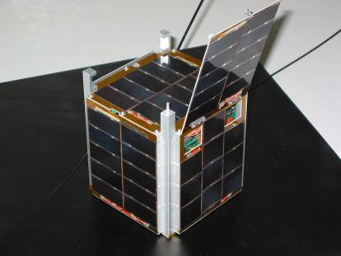
Fig.1 Tokyo Tech 1st Cubesat "CUTE-I"

2 . Cute-1.7 Project
At the beginning of 2004, we started to develop next CubeSat, "Cute-1.7". Cute-1.7 will be the second satellite made by LSS at Tokyo Tech after the first one, CUTE-I.

2.1 Purposes
The Cute-1.7 project has two goals^{[4]}. The first one is to facilitate future microsatellite development by demonstrating a new design methodology. To realize it, there are three aspects to consider: 1)reliable use of high performance and low cost commercial devices in space, 2)science mission, and 3)satellite disposal after the end of mission.
The second goal of the project is to share experiment opportunities with space engineering researchers, students, and others. Cute-1.7 satellite is equipped with three magnetic torquers and has program upload functionality in order to enable on-orbit experiments about advanced control algorithms.

2.2 Using PDA
Use of commercial-off-the-shelf devices is accelerated in space applications. Our previous CubeSat, CUTE-I, was almost composed of commercial grade parts. Especially, its FM transmitter and receiver, which are commercial handheld transceivers, have been functioning with no trouble for more than one year. Having this experience and having the objective to facilitate satellite development, in Cute-1.7 project, we are trying to be at the extreme end in terms of use of commercial products in a satellite. Cute-1.7 will depend on commercial finished products rather than only on commercial grade electric parts.
Its main computer is a Personal Digital Assistant (PDA) in Fig.2, size of which is about 100mm × 70mm. Fig.3 shows thirty functional blocks in Cute-1.7. Thirteen blocks out of thirty rely on finished products sold at ordinary electric goods stores, for example PDAs, memory cards, USB hub, digital cameras, handheld transceivers. In addition, PDA’s operating system is Windows CE.NET 4.1 and primary communication line is USB, making the system friendly to potential satellite users.
Of course, enough evaluation is required to make the total system reasonably reliable. To ensure that PDAs can function in space, a radiation protection circuitry was developed, and a radiation test at RCNP, Osaka University, was conducted. Test results showed that PDAs have low probability of SEU or SEL^{[5]}. In 800km circular orbit, SEU would occur once every two years. Probabilities are low enough for Cute-1.7 to function correctly for about a year.
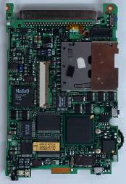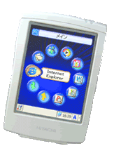
Fig.2 Hitachi PDA NPD-20JWL
internal circuit board(right), external view(left)

Fig.3 System Block Diagram

2.3 Attitude determination and control
2.3.1 Magnetic torquer
To demonstrate various attitude control algorithm, such as three-axis stabilization, detumbling, and spin-up, Cute-1.7 is equipped with three magnetic torquers placed orthogonal to each other. Each torquer is a coil without iron core, whose dimensions are 50mm × 80mm × 4mm (Fig.4). Maximum magnetic moment is designed to be 0.037Am². The magnetic torquers have potential to be most useful actuator for such a tiny satellite. A magnetic torquer has no moving parts, requires only electric currency and has structural simplicity. Nevertheless, to realize a reliable control algorithm is a challenge, and therefore, it requires more study. Cute-1.7 will be a test bed for advanced magnetic torquer controls, having capability of uploading a control software.

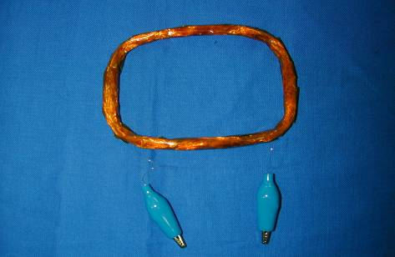
Fig.4 Prototype of Magnetic Torquer

2.3.2 Attitude determination
The satellite’s attitude determination system is composed of a three-axis gyrosensor, a three-axis magnetometer, a sun sensor and an earth sensor. The gyrosensor is a combination of three ADXRS gyroscopes by Analog Devices. The magnetometer is HMR2300 by Honeywell. The sun sensor is of most primitive type that is photodiode arrays, S6560 by Hamamatsu Photonics, attached to the surface of the satellite. Earth sensor is a CMOS camera, FlyCAM-CF by Animation Technology, with a fisheye lens. Before making decision, other configurations of attitude sensor system were considered.

2.4 Amateur radio service
Through the experiences of using amateur radio frequency to operate CUTE-I, it is very important to make cooperation with radio amateur community. A lot of telemetry data from CUTE-I owes contribution by radio amateurs. Cute-1.7 will have functionality as an on-orbit message box open to public with uplink in 1200MHz band and downlink in 430MHz band.
Since the satellite is planned to be inserted into low earth orbit, footprint of the satellite will not be so large and long distance communication via the satellite will not be possible. However, Cute-1.7 will enable communication between radio operators who are not in the same footprint simultaneously by storing and forwarding uploaded messages. Messages received by the satellite is stored and downlinked repeatedly for certain duration.

2.5 Science Misson - Demonstration of APD
Cute-1.7 aims at monitoring charged particles. An operational test of a very small, low power, and high sensitive sensor based on Avalanche Photo Diodes (APDs) and monitoring of low energy particle under 30keV using the APDs will be conducted. The APD sensor is now under development by Tokyo Tech astronomy laboratory.

2.6 Deorbit system
Cute-1.7 is equipped with satellite disposal system. Small satellites are usually designed for short lifetime, and that are likely to be used as a satellite constellation. The number of them should be large. Since the size of the proposed picosatellite is comparable to the smallest size catalogued by U.S. Space Command, it might be untraceable. The issue of satellite disposal may not, therefore, be left untackled. Guidelines by the Inter Agency Space Debris Coordination Committee (IADC) require that all satellites in low-Earth orbit should be de-orbited within no more than 25 years.
Given this reason, an use of electrodynamic tether shown in Fig.5 was studied. Some simulations showed in that a 100m electrodynamic tether with 0.2mA current flowing can deorbit the satellite in 25years, assuming the tether is always perpendicular to earth’s magnetic field. Because a 100m tether does not generate enough voltage to achieve self-sufficiency, an additional power supply will be used to increase potential of the anode. The satellite deorbit system consists of a carbon nanotube electron emitter, a tether, a high voltage power supply and a tether end deployment mechanism. A prototype of the electron emitter, as shown in Fig.6, is resin containing carbon nanotubes, pasted on the surface of a copper disk and its performance is being evaluated. Development of other parts is going as well.

Fig.5 Tether Deorbit System
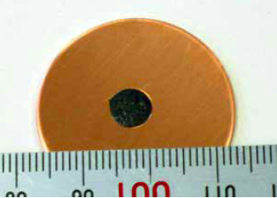
Fig.6 Prototype of Carbon-nano-tube Emitter

2.7 Present status and future works
On December 2004, an engineering model was completed and tested(Fig.7). Cute-1.7 is scheduled to be launched in 2005 aboard ISAS/JAXA solid-rocket M-V-8 and put into the elliptical orbit with the perigee altitude of 185km, apogee altitude of 800km and the inclination of 98.4 deg. Status of development will be updated on the website^{[5]}.

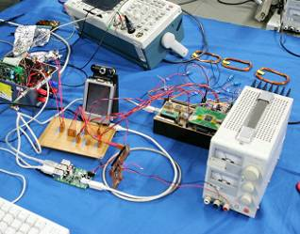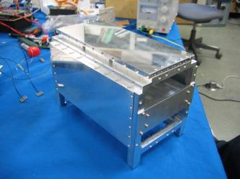
10cm
10cm
20cm
Fig.7 EM test (left), Body Structure (right)

3 . TSUBAME Project
Next to the Cute-1.7, the third small satellite project named "TSUBAME", which means a type of birds "swift" in Japanese, has started. TSUBAME has a size of 30cm × 30cm × 20cm and weight of 16kg classified into micro-satellite. Following sections describes a conceptual design of TSUBAME.

3.1 Purposes
We are always considering what an appropriate mission for just small satellite is. That means the mission is hard to be realized for bigger satellites. Given this question, we focus attention on an agile attitude control device called Control Momentum Gyro-scope (CMG). The great advantage of small satellites equipped with CMGs is that its possibility of high speed attitude control. So this time, we select the observation of high energy breakout phenomenon as a mission which requires high speed attitude change. With the cooperation of Tokyo Tech Astronomy laboratory，a conceptual design of satellite to observe burst sources including gamma-ray burst was conducted.

3.2 Mission background
Almost all astronomical objects emit electromagnetic waves. Especially X-ray and gamma-ray are the most direct probes to elucidate high energy phenomenon in space. The observation approach through electromagnetic waves is classified into photometry, spectroscopy, imaging and polarization observation. In the 1990’s, X-ray astronomy developed with lots of result from photometry, spectroscopy and imaging. But only polarization is still kept intact. Polarization is expected to elucidate origin of high energy radiation or magnetic structure, due to its completely different aspect of the observation approach.
TSUBAME observes polarization of astronomical burst objects such as gamma-ray burst, Magnetor (neutron-star with strong magnetic field) and active galaxy flare. Especially in case of gamma-ray burst, it should be noticed that burst duration is too short to observe. Sixty seconds after a burst occurrence, it becomes dark. Thus, rapid observation within 10~30 seconds is necessary.

3.3 Mission
It is unpredictable where and when Gamma-ray bursts occur. As shown in Fig.8, TSUBAME is equipped with coarse sensors to detect the burst occurrence and determine the direction with an accuracy of 10 degrees. Then, using high speed attitude control device, a polarimeter points to the gamma-ray burst quickly, and starts to observe polarization within 10 second after the burst occurrence. This means that the burst is still blight enough. It is the main characteristic of mission that TSUBAME can response to burst objects and observe them by itself promptly.

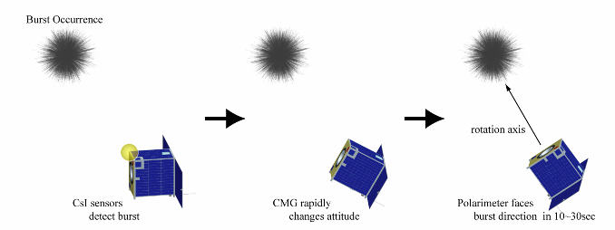
Fig.8 Mission Sequence

3.4 High-speed attitude control device – CMG
It is required for the satellite to equip high torque attitude control device to maneuver the attitude quickly toward the burst direction. LSS at Tokyo Tech studies about downsizing and control low of CMG^{[6]}. By applying our study results to small satellite, rapid attitude maneuver comes to be realized.
A CMG as shown in Fig.9 is a device that generates a strong torque, by changing the direction of gimbal which holds a flywheel rotating at constant speed. The output torque is vertical to the directions of both angular momentum and gimbal rotation, which is gyro effects. Also CMG is a torque amplifying device, due to the mechanism that small input to gimbal motor generates large torque. A high speed rotator has a capacity of large amount of angular momentum. However, CMG system becomes complex and large generally. Thus, CMG has been used for attitude change of large spacecrafts such as space stations in the past.
If CMG system size can be reduced reasonably, combination of high torque attitude control device and small satellite has a great benefit, and also has many other mission possibilities to be considered.
Through a careful consideration for downsizing CMG system to meet several design requirements, we obtained a design result of the specification as shown in Table1 in case of four CMGs in standard pyramid array.
Fig.10 shows a simulation result of rapid attitude change after burst detection, and that the design meets the mission requirement that the attitude change should be ended within 10 second. In the simulation, the initial quaternion q₀ and the final quaternion q_{f} are set as follows.
$q_{o}=[0,0,0,1]^{T}$, $q_{f}=[−0\text{.}\text{51},−0\text{.}\text{13},0,0\text{.}\text{85}]^{T}$
The adopted control law of CMG in the simulation includes an algorithm which solves the singularity avoidance problem. Optimization of the algorithm is one of current research topics.
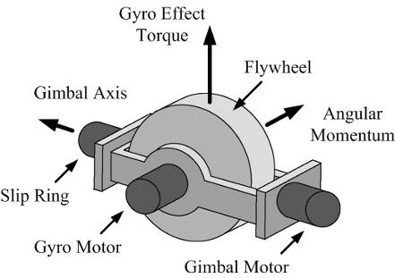
Fig.9 CMG
Table 1 CMG specifications
density(material: brass) | 8920kg/m³
wheel diameter | 50mm
wheel thickness | 12mm
wheel weight | 200g

(a) Attitude angle (quaternion)
(b) Angular velocity
Fig.10 CMG Simulation Results

3.5 Satellite system
A configuration, an external view and an equipment layout of TSUBAME are as shown in Table 2 and Fig.11. Two 30cm×30cm sized solar cell panels are deployed to generate the necessary power.

Table.2 Satellite Configuration
Size | 30cm×20cm×30cm
Weight | 16kg
Orbit | Sun-synchronize：Altitude 800km  Inclination 98.6°
Life-time | 1 year
Mission | Gamma-ray burst direction sensor  (CsI & APD)  Polarimeter (P-Sci & PMT)
ADCS | Control：CMG, Magnet torquer  Determination：Gyro, Sun sensor,  Magnet sensor
C&DH | 32bit MPU (COTS)  SDRAM 32MB
Comm. | S-band transmitter(Mission data)  BPSK 200kbps  S-band transmitter（House keeping data）  BPSK 9600bps  S-band receiver（Command data）  PM 9600bps  S-band  mono pole / patch antenna
EPS | Multi-junction cell（efficiency 22%）  Power generation approx. 40W  Li-ion battery  Peak power tracking system
Structure | Paddle unfolding mechanism  Passive thermal control
20cm
30cm
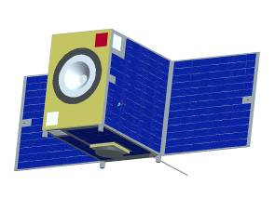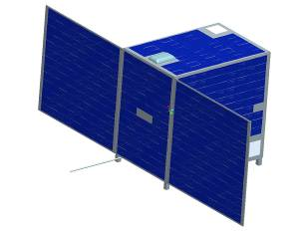
30cm
(a) External View

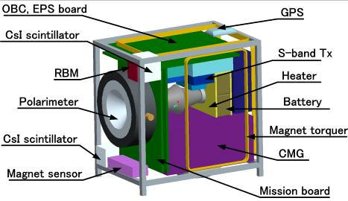
(b) Equipment Layout
Fig.11 TSUBAME satellite

3.6 Present status and future works
TSUBAME satellite development is in conceptual design level. We will exanimate the design in more detail and go on to BBM fabrication phase. Launch date is assumed in 2007.

4 . Conclusions
In this paper, two satellites development projects called "Cute-1.7" and "TSUBAME" were introduced, and their system characteristics and current status were explained. Cute-1.7 is a 2kg Cubesat using PDA as a main computer, and has a science mission of on-orbit demonstration for an advanced high quality APD sensors. TSUBAME is expected to pursue a full-fledged science observation mission, and also demonstrate small-sized CMG system performance for prompt attitude maneuvers.

5 . References
[1] CUTE-I official website
http://lss.mes.titech.ac.jp/ssp/cubesat/index_e.html
[2] Koji Nakaya, Kazuya Konoue, Hirotaka Sawada, Kyoichi Ui, Hideto Okada, Naoki Miyashita, Masafumi Iai, Tomoyuki Urabe, Nobumasa Yamaguchi, Munetaka Kashiwa, Kuniyuki Omagari, Ikutaro Morita and Saburo Matunaga, "Tokyo Tech CubeSat: CUTE-I - Design & Development of Flight Model and Future Plan -," 21st AIAA International Communication Satellite System Conference (ICSSC) & Exhibit, Yokohama, April 15-19, 2003, AIAA Paper 2003-2388.
[3] Masafumi Iai, Hirotaka Sawada, Koji Nakaya, Kyoichi Ui, Naoki Miyashita, Munetaka Kashiwa, Nobumasa Yamaguchi and Saburo Matunaga "Orbital Data Analysis of Picosatellite CUTE-I," 24th International Symposium on Space Technology and Science, Miyazaki, June 1-6, 2004, 2004-f-08.
[4] Masafumi Iai, Kazuya Konoue, Koji Nakaya, Kyoichi Ui, Naoki Miyashita, Masashi Asami, Wataru Miyazawa, Kuniyuki Omagari, Yusuke Funaki, Katsutoshi Imai, Kei Miyamoto, Hideyuki Yabe, Ken Fujiwara, Shinji Masumoto, Takeshi Usuda and Saburo Matunaga "A PDA-Controlled Pico-Satellite, Cute-1.7, and its Radiation Protection," The 18th Annual AIAA/USU Conference on Small Satellites, Logan, Utah, August 9-12, 2004.
[5] Cute-1.7 official website
http://lss.mes.titech.ac.jp/ssp/cute1.7/index_e.html
[6] Kuniyuki Omagari and Saburo Matunaga "Study for Design and Control of Control Moment Gyro for Agile Attitude Maneuver of Small Satellites," 47th Space Sciences and Technology Conference, Fukui, Japan, Nov. 4-6, 2004, pp.310-315 (in Japanese)

